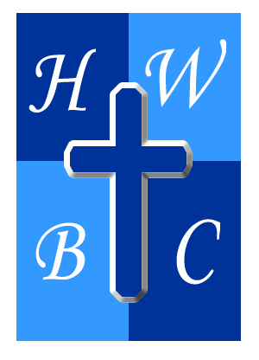
Summer on Mission
Week 2
Serve Where You Stand
John 13:12–17

1: You Don’t Need a Title to Serve—Just a Towel
Scripture: “If I then, your Lord and Teacher, have washed your feet, you also ought to wash one another’s feet.” – John 13:14
- Jesus used a ________________, not a throne, to display His authority.
- Serving others isn’t a downgrade—it’s a ________________ of spiritual strength.
- Your greatest impact won’t come from your position, but from your ________________.

2: Your Platform Is Wherever Your Feet Are
Scripture: “For I have given you an example, that you also should do just as I have done to you.” – John 13:15
- You don’t have to go on a mission trip to live on ________________.
- Ministry happens when you’re present, not when you’re ________________.
- If God can use a basin and a towel, He can use your ________________.

3: You Are Blessed Not Just by Knowing—But by Doing
Scripture: “If you know these things, blessed are you if you do them.” – John 13:17
- Obedience unlocks ________________.
- It’s not enough to be informed—we must be ________________.
- Faith without action is ________________.

R.A.P. Challenge
- Reflect: Who has God placed in your path this week that you can serve? What areas have you been overlooking as opportunities for ministry?
- Act: Find a tangible way to serve someone today—at home, at work, in your neighborhood, or at church. Let it be personal, intentional, and unseen.
- Pray: “Jesus, thank You for showing me that greatness is found in service. Help me to take up the towel, not for attention, but for obedience. Open my eyes to serve right where I am and to live like You in every room I walk into. Amen.”

