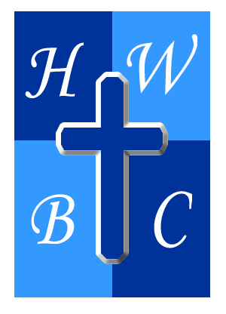
Speak Life: From Mouth to Miracle
Week 1: The Creative Power of Words
Scripture: Proverbs 18:21 — “Death and life are in the power of the tongue…”
1: Your Words Have Power
- Your words are not empty—they are __________ tools or destructive _________.
- Every sentence you speak is a __________ that produces a harvest.
- Like God, you have the ability to shape your life with your __________.

2: God Spoke Creation, Not Just Action
- God didn’t build with His hands—He created with His __________.
- Before the miracle is seen, a __________ must be spoken.
- Speaking the Word aligns us with the __________ of God.

3: Speak What God Said, Not What You See
- We walk by __________, not by sight.
- Ezekiel didn’t speak about the bones—he __________ to them.
- Your language must match your __________, not your frustration.
R.A.P. Challenge (Reflect – Act – Pray)
- Reflect: What words have I spoken recently that do not align with God’s promises?
- Act: Write down 5 Scriptures this week and __________ them out loud every morning.
- Pray: “Lord, teach me to speak life. Let my mouth be filled with Your Word and my heart renewed by Your truth.”

