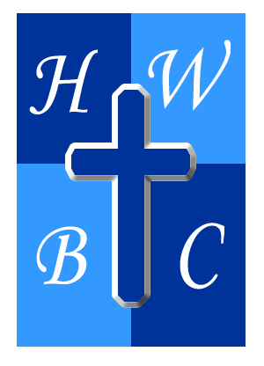
Speak Life: From Mouth to Miracle
Week 2: Watch Your Mouth
Scripture: James 3:5-10 — “5 Likewise, the tongue is a small part of the body, but it makes great boasts. Consider what a great forest is set on fire by a small spark. 6 The tongue also is a fire, a world of evil among the parts of the body. It corrupts the whole body, sets the whole course of one’s life on fire, and is itself set on fire by hell. 7 All kinds of animals, birds, reptiles and sea creatures are being tamed and have been tamed by mankind, 8 but no human being can tame the tongue. It is a restless evil, full of deadly poison. 9 With the tongue we praise our Lord and Father, and with it we curse human beings, who have been made in God’s likeness. 10 Out of the same mouth come praise and cursing. My brothers and sisters, this should not be.”
1. The Tongue Is a __________ or a __________. James 3:5–6
- The tongue is small, but its __________ is massive.
- It can be a fire that __________ or a fountain that refreshes.
- Words either carry the smoke of __________ or the stream of life.

2. The Tongue Is Tamed by __________, Not __________. James 3:7–8
- Humans can tame wild animals, but we struggle to tame the __________.
- Emotions are real, but they shouldn’t be our __________.
- The tongue is restrained when the __________ of God controls the heart.

3. __________ Talk Destroys __________. James 3:9–10
- We bless God and curse people made in His __________—it shouldn’t be this way.
- A forked tongue reveals a __________ heart.
- __________ words reflect a surrendered life.

R.A.P. Challenge
Reflect: What patterns of speech reveal my need for growth in Christ?
Act: Identify one situation this week where you’ll intentionally choose words that build instead of burn.
Pray: “God, train my tongue to speak with grace. Help me pause before I speak and choose words that honor You and reflect maturity.”

