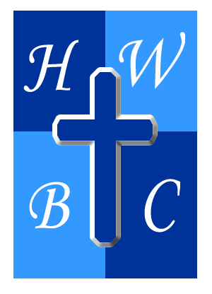
Speak Life: From Mouth to Miracle
Week 3: Speak Life Over Yourself
Scripture: Psalm 19:14 – “Let the words of my mouth and the meditation of my heart be acceptable in your sight, O Lord, my rock and my redeemer.”
1. Silence the Inner __________.
Scripture: Psalm 19:14
- Most of the __________ we believe were spoken by us—in our own head.
- The inner critic says “You’re not enough.” God says “I’ve made you more than __________.”
- If God wouldn’t say it about you, why do you keep __________ it?

2. Speak __________ in the Face of __________.
Scripture: Proverbs 24:16 – “The righteous fall seven times, but rise again…”
- Faith doesn’t deny failure—it declares God is __________ than failure.
- Your words can either __________ your past or release your future.
- David encouraged himself in the __________ (1 Samuel 30:6).

3. Proclaim Who __________ Says You Are.
Scripture: Ephesians 2:10 – “We are His workmanship…”
- Stop repeating what people __________ you—start declaring who God created you to be.
- You are not your past, your pain, or your performance—you are God’s __________.
- Your identity is not based on __________—it’s rooted in Scripture.

R.A.P. Challenge
Reflect: What negative things have I spoken over myself that don’t align with God’s Word?
Act: Write and declare 3 identity-based Scriptures daily (e.g., “I am fearfully and wonderfully made”).
Pray: “Lord, teach me to speak life over myself. Help me see myself as You see me, and silence every voice that contradicts Your truth.”

