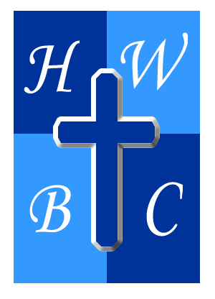
Freedom Unchained
Week 1: The Illusion of Freedom
Scripture: John 8:31–33 - “So Jesus said to the Jews who had believed him, ‘If you abide in my word, you are truly my disciples, and you will know the truth, and the truth will set you free.’ They answered him, ‘We are offspring of Abraham and have never been enslaved to anyone. How is it that you say, “You will become free”?’”

1: Cultural Freedom Can Conceal Spiritual Slavery
- They had religious _______ but lacked spiritual awareness.
- We often mistake civic _______________ for soul liberty.
- We say we’re ________ because of our rights—but what about our _________ ?

2: Self-Deception Blocks Transformation
- The Jews ___________ Egypt, Babylon, Assyria, Persia, Greece, and Rome.

- Spiritual __________ causes historical __________ and present blindness.

- We cannot be _________ from what we __________ to face.

3: Only the Word Reveals What’s Really Binding You
- Abiding in the Word helps you detect _________ freedom.

- It doesn’t just tell you what’s wrong—it shows you how to ________ right.

- Many are bound by _________ they never challenged.

R.A.P. Challenge (Reflect – Act – Pray)
- Reflect: Where am I claiming freedom but still living bound?

- Act: Spend 15 minutes each day this week abiding in God’s Word (start with John 8).

- Pray: “Lord, open my eyes to the areas where I’m not as free as I think. Help me trade illusion for truth.”

