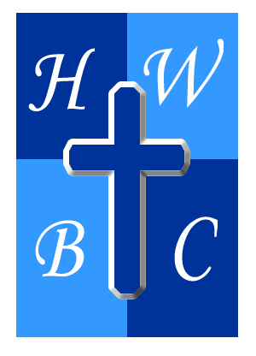
Freedom Unchained
Week 2: The Power of Truth
Scripture: John 8:32 - ““Then you will know the truth, and the truth will set you free.”
1: Truth Is a Person, Not Just a Principle
“You will know the truth…”
- Jesus is the __________ of truth (John 14:6).
- Relationship leads to __________.
- Abiding activates __________.

2: Truth Exposes What You’ve Been Believing That’s False

“Then you will know the truth…”

Truth confronts __________ narratives.

Truth dismantles __________ security.

Truth uproots __________ gods.

3: Truth Frees You to Become Who God Intended You to Be

“…and the truth will set you free.”

Freedom is about __________.

Truth breaks __________ and __________.

Truth rewrites your __________.
R.A.P. Challenge (Reflect – Act – Pray)
Reflect: What false beliefs have been shaping your behavior or identity?
Act: Write down 3 lies you’ve believed—and find 3 Scriptures that replace them with truth.
Pray: “Jesus, You are the Truth. Expose every lie that’s been holding me back, and help me walk in Your Word.”

