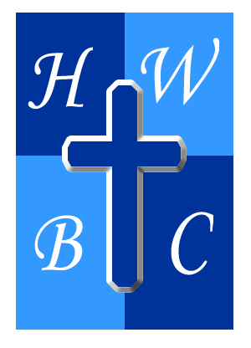
Freedom Unchained
Week 3: The Real Master
Scripture: John 8:34–35 - “Jesus replied, ‘Very truly I tell you, everyone who sins is a slave to sin. Now a slave has no permanent place in the family, but a son belongs to it forever.’”
1: Sin Is Not a Struggle—It’s a Master When You Stop Resisting
“Everyone who sins is a slave to sin.”
- Jesus teaches that sin is not just an __________; it’s a master with a hold.
- When sin is unchallenged, it becomes your __________.
- Many believe they’re in control—but sin always takes __________ than it promises.

2: Slavery to Sin Keeps You from Belonging Where You Were Meant to Be

“A slave has no permanent place in the family…”

Sin not only __________—it separates.

Slaves didn’t __________. They had no lasting __________.

When we’re owned by sin, we __________ from the blessings and intimacy of being God’s child.

3: Freedom Begins When You Shift Masters

“But a son belongs to it forever.”

The Son (Jesus) sets us free to become __________ and __________.

Sons don’t live in __________ of being kicked out—they live in __________ and grace.

You don’t need to __________—you just need to __________.
R.A.P. Challenge (Reflect – Act – Pray)
Reflect: What sin patterns have subtly taken master status in your life?
Act: Identify one area where sin has been dictating your behavior—confess it and submit it to Christ.
Pray: “Father, I no longer want to live like a slave. Help me walk in the freedom and identity of being your child.”

