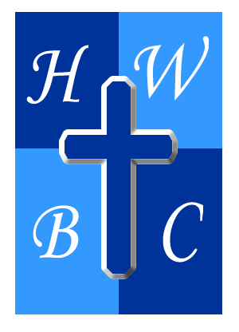
Am I A Christian?
Week 4: Fruit Check
Scripture: 1 John 2:3–6 -“We know that we have come to know Him if we keep His commands… Whoever claims to live in Him must live as Jesus did.”
1. Obedience Is the Evidence of Authentic Faith
- Obedience is not about __________________ but about posture.
- Real faith leads to real change—and real _________________.
- The test of salvation is not your church __________________; it’s your __________________.

2: Hypocrisy Undermines Your Assurance
- God takes false ________________ seriously—He calls it _____________.
- When your _____________ doesn’t match your talk, your witness is _______________.
- You can ______________ people with performance—but you can’t fake __________.

3: Christlikeness Is the Goal, Not the Bonus
- Following Jesus isn’t about ____________________ —it’s about ______________.
- The more you ____________ in Christ, the more you’ll begin to _________ like Him.
- If He’s truly in you, He will _____________ to show through you.
R.A.P. Challenge (Reflect – Act – Pray)
Reflect: Where am I claiming Christ but not imitating Him?
Act: Pick one clear command of Jesus this week—and do it with intention.
Pray: “Lord, I don’t want to look saved—I want to live saved. Make me more like You.”

