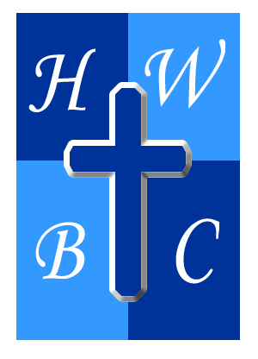
The Uncommon Gift
God’s greatest gift came in a way no one anticipated — humble, vulnerable, yet full of glory.
Week 3: The Gift That Keeps Giving
John 7:37–39 (NIV) - 37 On the last and greatest day of the festival, Jesus stood and said in a loud voice, “Let anyone who is thirsty come to me and drink. 38 Whoever believes in me, as Scripture has said, rivers of living water will flow from within them.”[a] 39 By this he meant the Spirit, whom those who believed in him were later to receive. Up to that time the Spirit had not been given, since Jesus had not yet been glorified.
1: The Spirit Satisfies Our Deepest Thirst (John 7:37)
- Only the Spirit can quench the soul’s ________.
- Spiritual thirst is an ________ from God.
- Jesus offers the Spirit to ________ who will come.

2: The Spirit Empowers Us for Daily Living (John 7:38)
- The Spirit flows ________, not occasionally.
- The Spirit equips us to do God’s ________.
- The Spirit turns receivers into ________.

3: The Spirit Produces Lasting Change (John 7:39)
- The Spirit transforms our ________.
- The Spirit anchors us in ________.
- The Spirit keeps the work of ________ alive in us.
R.A.P. Challenge (Reflect – Act – Pray)
Reflect: What areas of your life are running dry because you haven’t allowed the Spirit to refresh them?
Act: Invite the Holy Spirit to lead and empower you daily this week.
Pray: “Holy Spirit, flow in me, fill me, and transform me from the inside out.”

