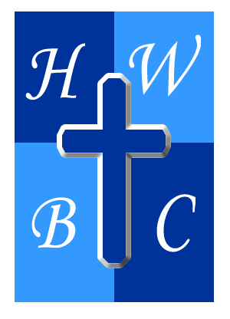
Living in the Overflow
Week 1
The Source of the Overflow
Scripture: Psalm 23:1–6 (NIV)
“The Lord is my shepherd, I lack nothing… my cup overflows.”

1. Overflow Begins with Ownership
• When God is your Shepherd, you stop trying to be your own _________________.
• _________________ determines trust; stewardship determines obedience.
• Overflow flows from _________________, not control.

2. Overflow Is Connected to Guidance
• God’s guidance always leads to _________________.
• If you’re always drained, you may be following the wrong ________________.
• Still waters require ___________ — rushing waters require survival.

3. Overflow Is Sustained by Presence
• God’s _____________ changes the environment, not the enemies.
• Overflow happens in the presence of God, not the absence of ________________.
• When God fills your cup, it spills into ___________________ lives.

R.A.P. CHALLENGE (Reflect – Act – Pray)

Reflect: Who or what has been functioning as your shepherd?

Act: This week, intentionally surrender one area you’ve been controlling back to God.

Pray: “Lord, help me trust You as my source and lead me into Your overflow.”

