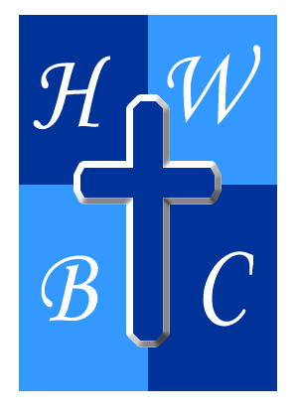
Living in the Overflow
Week 4
Overflow Is Meant to Flow Through You
Scripture:Genesis 12:1–3(NIV)
1 The Lord had said to Abram, “Go from your country, your people and your father’s household to the land I will show you. 2 “I will make you into a great nation, and I will bless you; I will make your name great, and you will be a blessing. 3 I will bless those who bless you, and whoever curses you I will curse; and all peoples on earth will be blessed through you.”

1. God Blesses with Intentional Purpose
• God’s blessings always carry _________________ .
• Overflow reveals what God _________________ you with.
• When God increases you, He’s expanding your _________________.

2. God’s Blessing Must Keep Moving
• Blessing that _________________ with you limits God’s flow.
• God pours through people who stay ________________.
• Overflow requires _____________, not ability.

3. Overflow Impacts More Than You
• Overflow creates _____________ beyond your lifetime.
• Your ________________ opens doors for others.
• Overflow turns generosity into ___________________ .

R.A.P. CHALLENGE (Reflect – Act – Pray)

Reflect: Where has God blessed me that I’ve kept to myself?

Act: Be intentional this week: bless someone with time, encouragement, service, or resources.

Pray: “Lord, make me a vessel You can pour through freely.”

