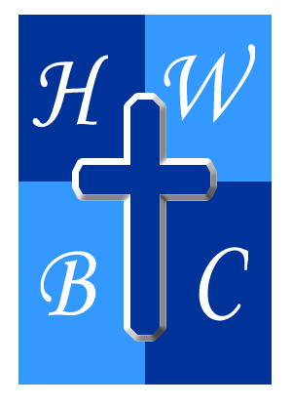
The Power of I AM
Week 2
The Lie in My I Am
Scripture:Genesis 3:1–10
1: Identity Begins With Revelation, Not Self-Reflection
- Identity flows from __________, not self
- Confusion comes from __________
- God’s nature is the __________ for my identity

2: My Identity Is Anchored in God’s Character
- Because He is faithful, I am __________
- Because He is provider, I am not __________
- Because He is present, I am not __________

3: I Must Align My “I Am” With His “I AM”
- __________ with God matters
- Confession aligns me with __________
- I live __________ identity, not for it

R.A.P. Challenge

Reflect: What lie about myself have I been believing?

Act: Replace that lie with a Scripture-based truth.

Pray: “Lord, expose every lie I’ve believed about myself…”

