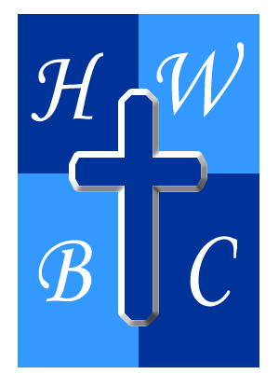
THE CHECK BEFORE THE WRECK
Week 3

Self-Check Before I Mess Up

Psalm 139:23–24 - ²³ Search me, O God, and know my heart! Try me and know my thoughts! ²⁴ And see if there be any grievous way in me, and lead me in the way everlasting![
1 Corinthians 11:28 - ²⁸ Let a person examine himself, then, and so eat of the bread and drink of the cup.

SELF-EXAMINATION IS A SIGN OF SPIRITUAL MATURITY

Mature people ask God to __________ what they cannot see.

Self-reflection prevents spiritual __________.

Humility opens the door for __________.

UNCHECKED ISSUES ALWAYS GROW

Little compromises become big __________.
Unhealed hurt produces unhealthy __________.

Secret sin thrives in __________.

GOD’S CHECKS ARE MEANT TO LEAD TO HEALING

Conviction is different from __________.
Confession breaks the power of hidden __________.
Daily checks create long-term __________.

R.A.P. CHALLENGE

Reflect: What hidden issue, unhealthy pattern, or unresolved hurt have you been avoiding?
Act: Spend intentional time this week asking God to reveal areas of your life that need healing, correction, or accountability.
Pray: “Lord, search my heart, expose what needs to change, and help me become who You created me to be.”

