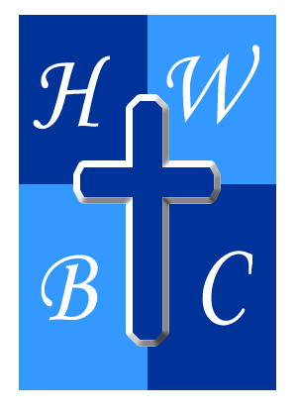
THE CHECK BEFORE THE WRECK
Week 4

Help Me Before I Hit The Wall

Galatians 6:1–2 - Brothers, if anyone is caught in any transgression, you who are spiritual should restore him in a spirit of gentleness. Keep watch on yourself, lest you too be tempted. ² Bear one another's burdens, and so fulfill the law of Christ.
Ecclesiastes 4:9–10 - ⁹ Two are better than one, because they have a good reward for their toil. ¹⁰ For if they fall, one will lift up his fellow. But woe to him who is alone when he falls and has not another to lift him up!
GOD NEVER INTENDED FOR YOU TO FIGHT ALONE

The enemy attacks __________ people first.
__________ keeps people from asking for help.
God often sends help through __________.

BIBLICAL ACCOUNTABILITY RESTORES, NOT DESTROYS

Healthy accountability speaks truth in __________.

Restoration requires __________.

Restored people should help __________ others.

ACCOUNTABILITY BUILDS A STRONGER CHURCH

Community creates spiritual __________.

Accountability helps prevent future __________.

Healing happens faster in __________.

R.A.P. CHALLENGE
Reflect: What burden, struggle, or hidden issue have you been trying to carry alone?
Act: Reach out to a trusted believer, mentor, pastor, or accountability partner and allow them to walk with you in an area where you need support.
Pray: “Lord, give me the humility to receive help, the courage to be honest, and the wisdom to stay connected to healthy community.”

