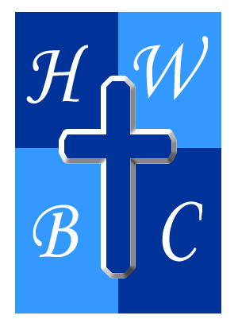
Free Indeed
Week 2

What’s Holding You Hostage

John 8:34–36: ³⁴ Jesus answered them, “Truly, truly, I say to you, everyone who practices sin is a slave^{[a]} to sin. ³⁵ The slave does not remain in the house forever; the son remains forever. ³⁶ So if the Son sets you free, you will be free indeed.

SIN NEVER STAYS SMALL

The chains that bind people today often started as __________ they thought they could __________.

Every repeated __________ makes the next compromise __________.

Anything that controls your emotions, decisions, or priorities more than Christ has become a __________.

BONDAGE OFTEN DISGUISES ITSELF

A fish never sees the __________ because it’s focused on the __________.

Many people __________ the very things God is trying to __________ them from.

God never intended your __________ to become your __________.

JESUS CAME TO BREAK THE CHAIN

Healing begins when __________ replaces __________.

The freedom Christ offers comes through surrendering __________ to __________.

Many believers are living in __________ whose doors Christ has already __________.

R.A.P. CHALLENGE

Reflect: What area of your life has more influence over your decisions than Jesus?
Act: Identify one unhealthy habit, attitude, or dependency and begin replacing it with a godly habit this week.
Pray: Lord, reveal every chain that is trying to control my life. Give me the courage to be honest, the humility to surrender, and the faith to walk in the freedom You have provided. In Jesus’ name, Amen.

