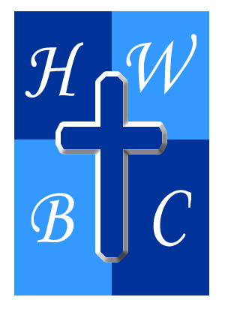
CORE: BUILT DIFFERENT
Week 3

INTEGRITY: Living What You Believe
Psalm 15:1–2

1: INTEGRITY MEANS YOUR WALK MATCHES YOUR WORDS
Psalm 15:2 — “The one whose walk is blameless, who does what is righteous…”

A. Integrity closes the ____________ between what you say and what you do.

B. Integrity is tested when obedience becomes ____________.

C. Integrity means your ____________ travels with you.

2: INTEGRITY IS BUILT IN PRIVATE BEFORE IT IS SEEN IN PUBLIC
Matthew 23:27–28 — Jesus compares the religious leaders to whitewashed tombs—beautiful externally but corrupt internally.

A. Your ____________ life reveals your real priorities.

B. Private ____________ eventually produces public consequences.

C. What you practice ____________ prepares you for public pressure.

3: INTEGRITY PRODUCES VISIBLE FRUIT
Luke 6:44 — “Each tree is recognized by its own fruit.”

A. Integrity produces ____________.

B. Integrity produces ____________.

C. Integrity produces ____________.

R.A.P. CHALLENGE
REFLECT: Where is the biggest gap between what I say I believe and how I'm actually living? Is there an area of my private life that doesn't match my public profession?
ACT: Choose one area this week where your behavior needs to catch up with your belief. Don't try to fix everything at once. Identify it, find the Scripture that addresses it, and make one concrete change. If necessary, bring someone trustworthy into that area for accountability.
PRAY: “God, make me whole. Remove the gap between what I say and how I live. Give me integrity when people are watching and when nobody is watching. Strengthen my character so it can support the calling You have placed on my life. Let my words, choices, relationships, and actions reflect the faith I profess. Help me not just look the part, but live the life. In Jesus' name, Amen.”

